Kernel-

it acts as an interface between hardware and software

Android:

android is a software package and linux based kernel operating system for mobile devices such as tablet computer and smart phones

DVM:

Delvik virtual machine is the virtual machine that will be launching our application.previous AVT used to be there(Android virtual terminal) as it is used to take long time to run the app bcz of some libraries so later then DVM was introduced .

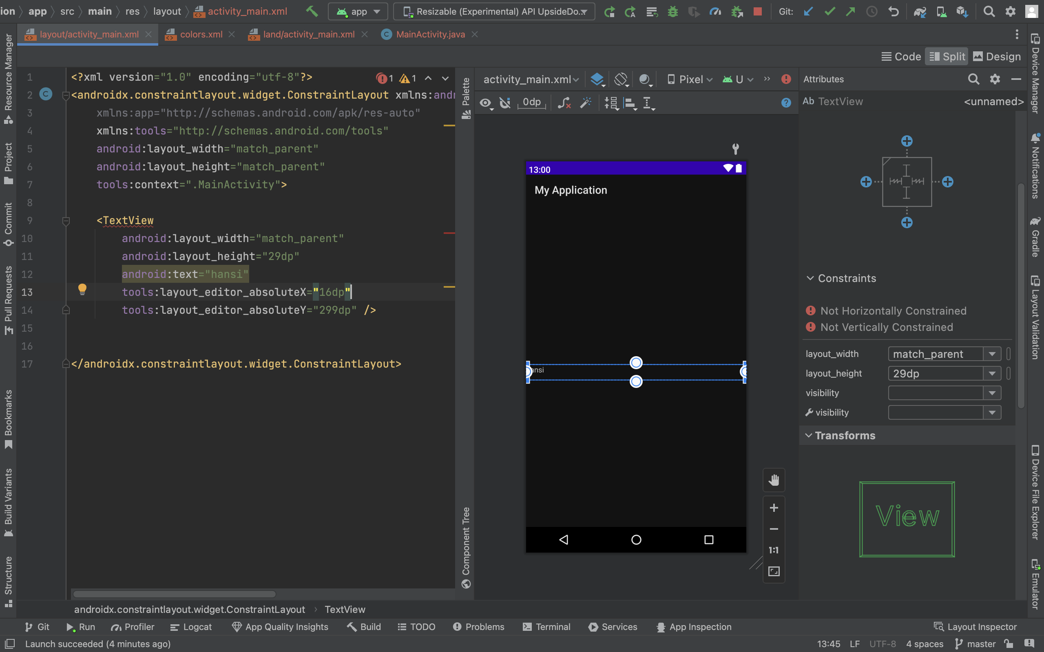

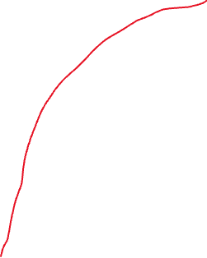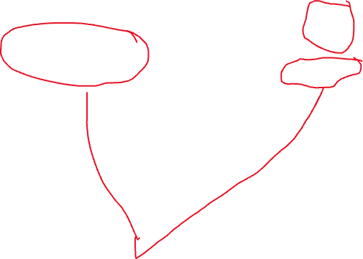

See here the erroes not horizontally constrained and not vertically constrained means that in design u might dragged the text to whare ever u want but it will be upto the design itself but when the emulator is launched the output might not be displayed in the desired place it might be displayed somewhere else.bcz code wont be in code part but the below code will be added but this code Is responsible for displaying in the design part itself

tools:layout_editor_absoluteX="16dp"  
tools:layout_editor_absoluteY="299dp"

but if u want the the same to be displayed u need to add respective code to add that using ui do follow below steps

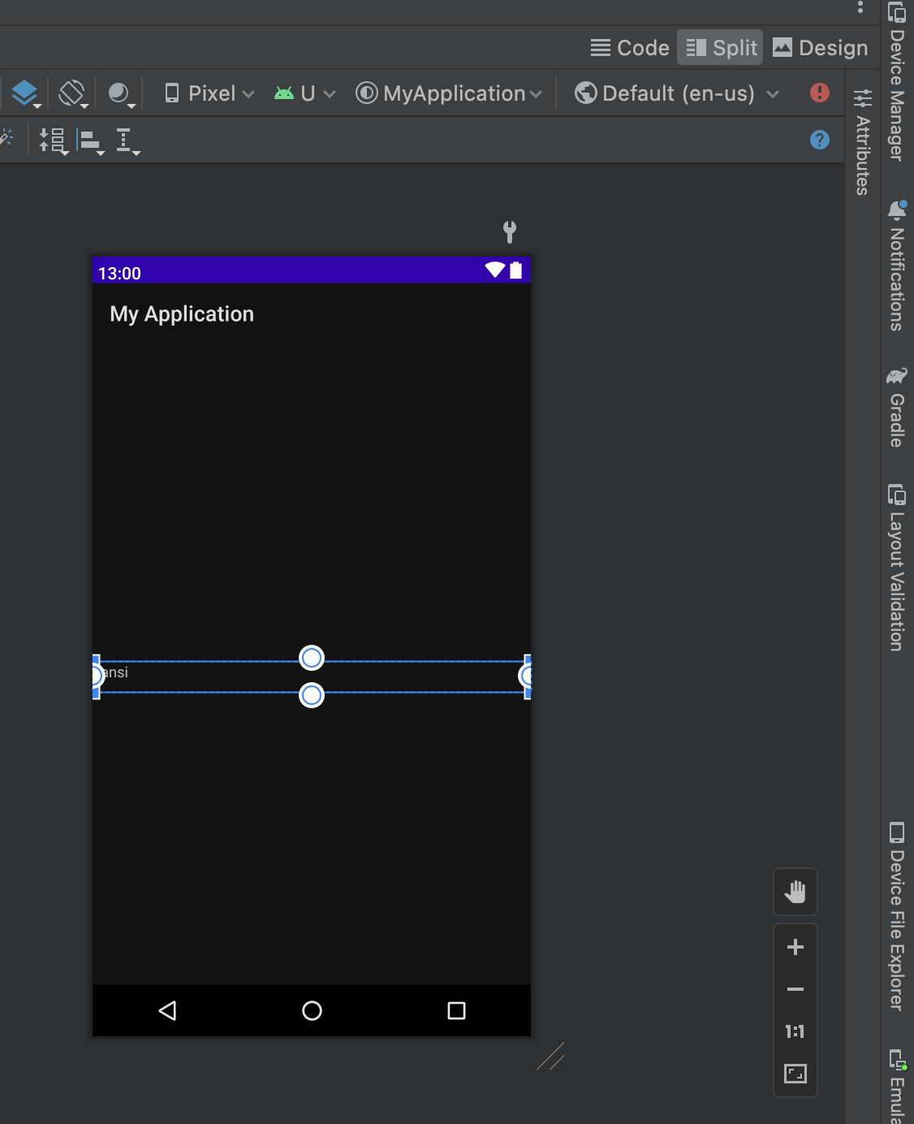

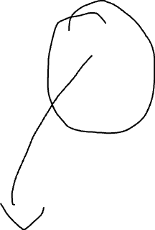

Click on attributes then. U will be displayed as below

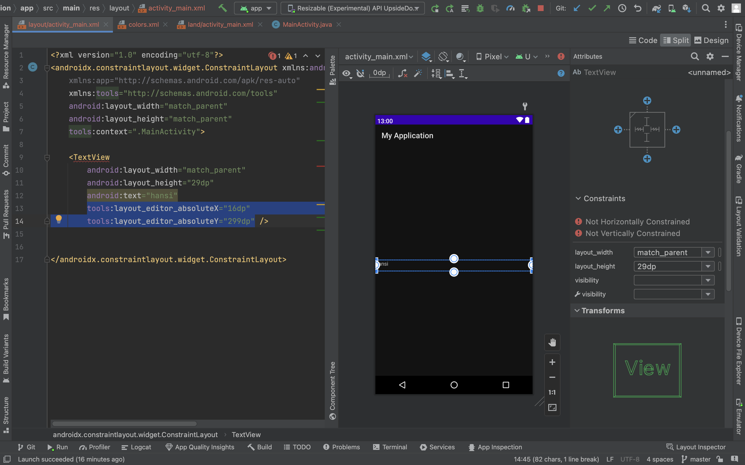

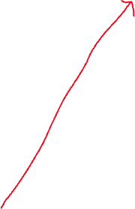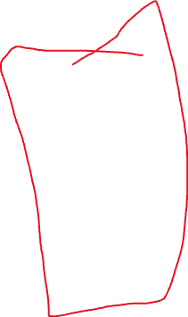

See this is the attribute section and if u want to add the respective code then click on the plus symbols then respective code will be add and respective error will be solved



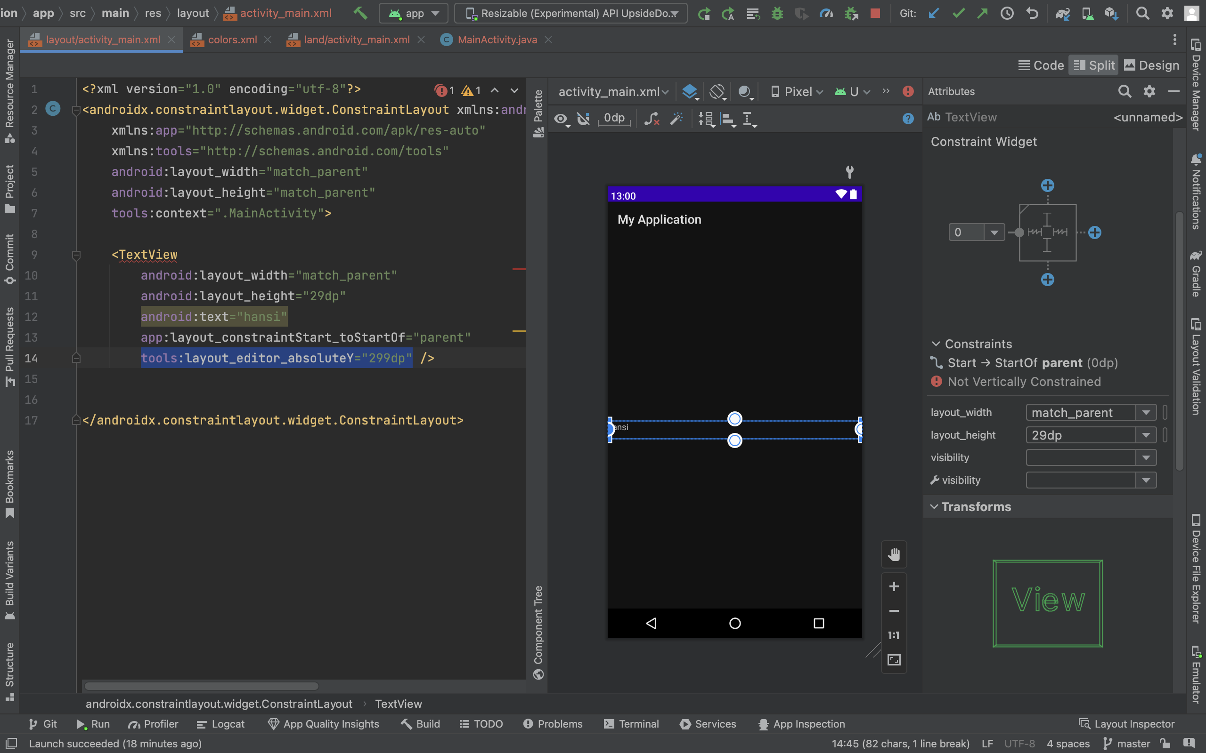

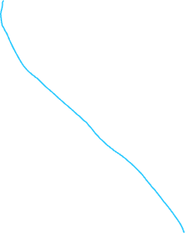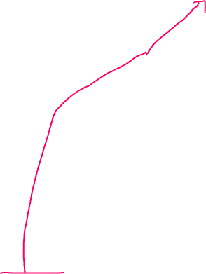

See here we removed error of not horizontally constrained by clicking on the plus symbol and respective code is added.now if u run the app u will see the output at desired place(NOTE:make sure both the errors are solved as in the above way)see the output in below picture



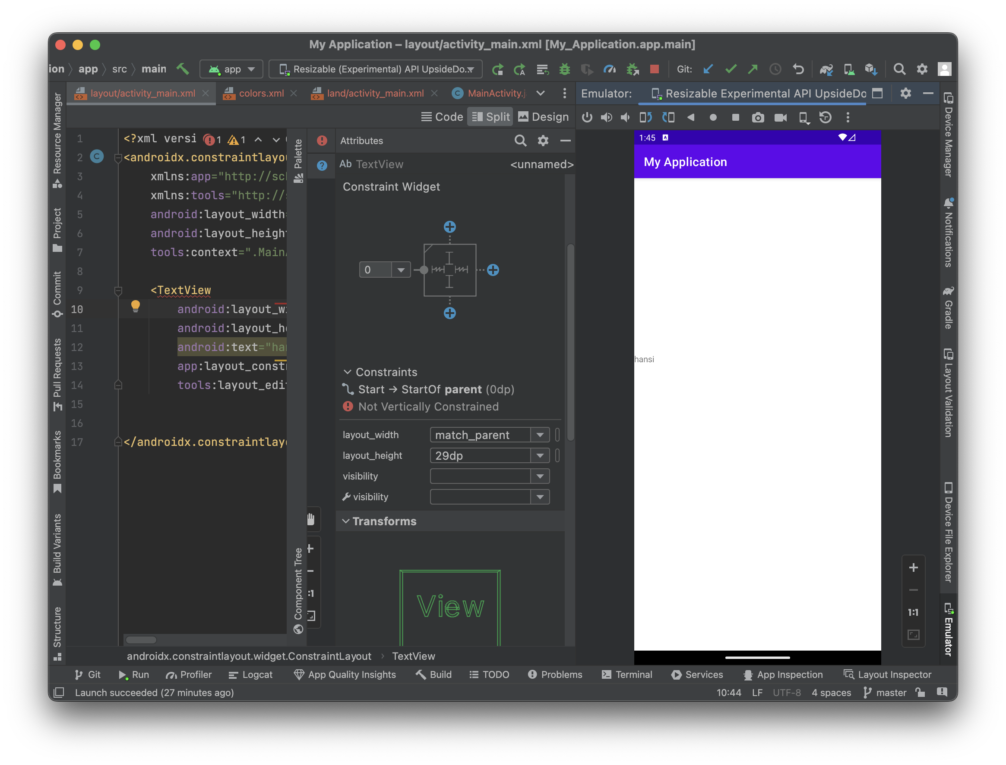

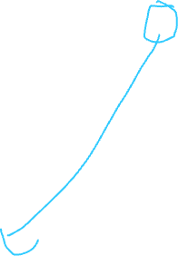

See we got output at desired place where we want

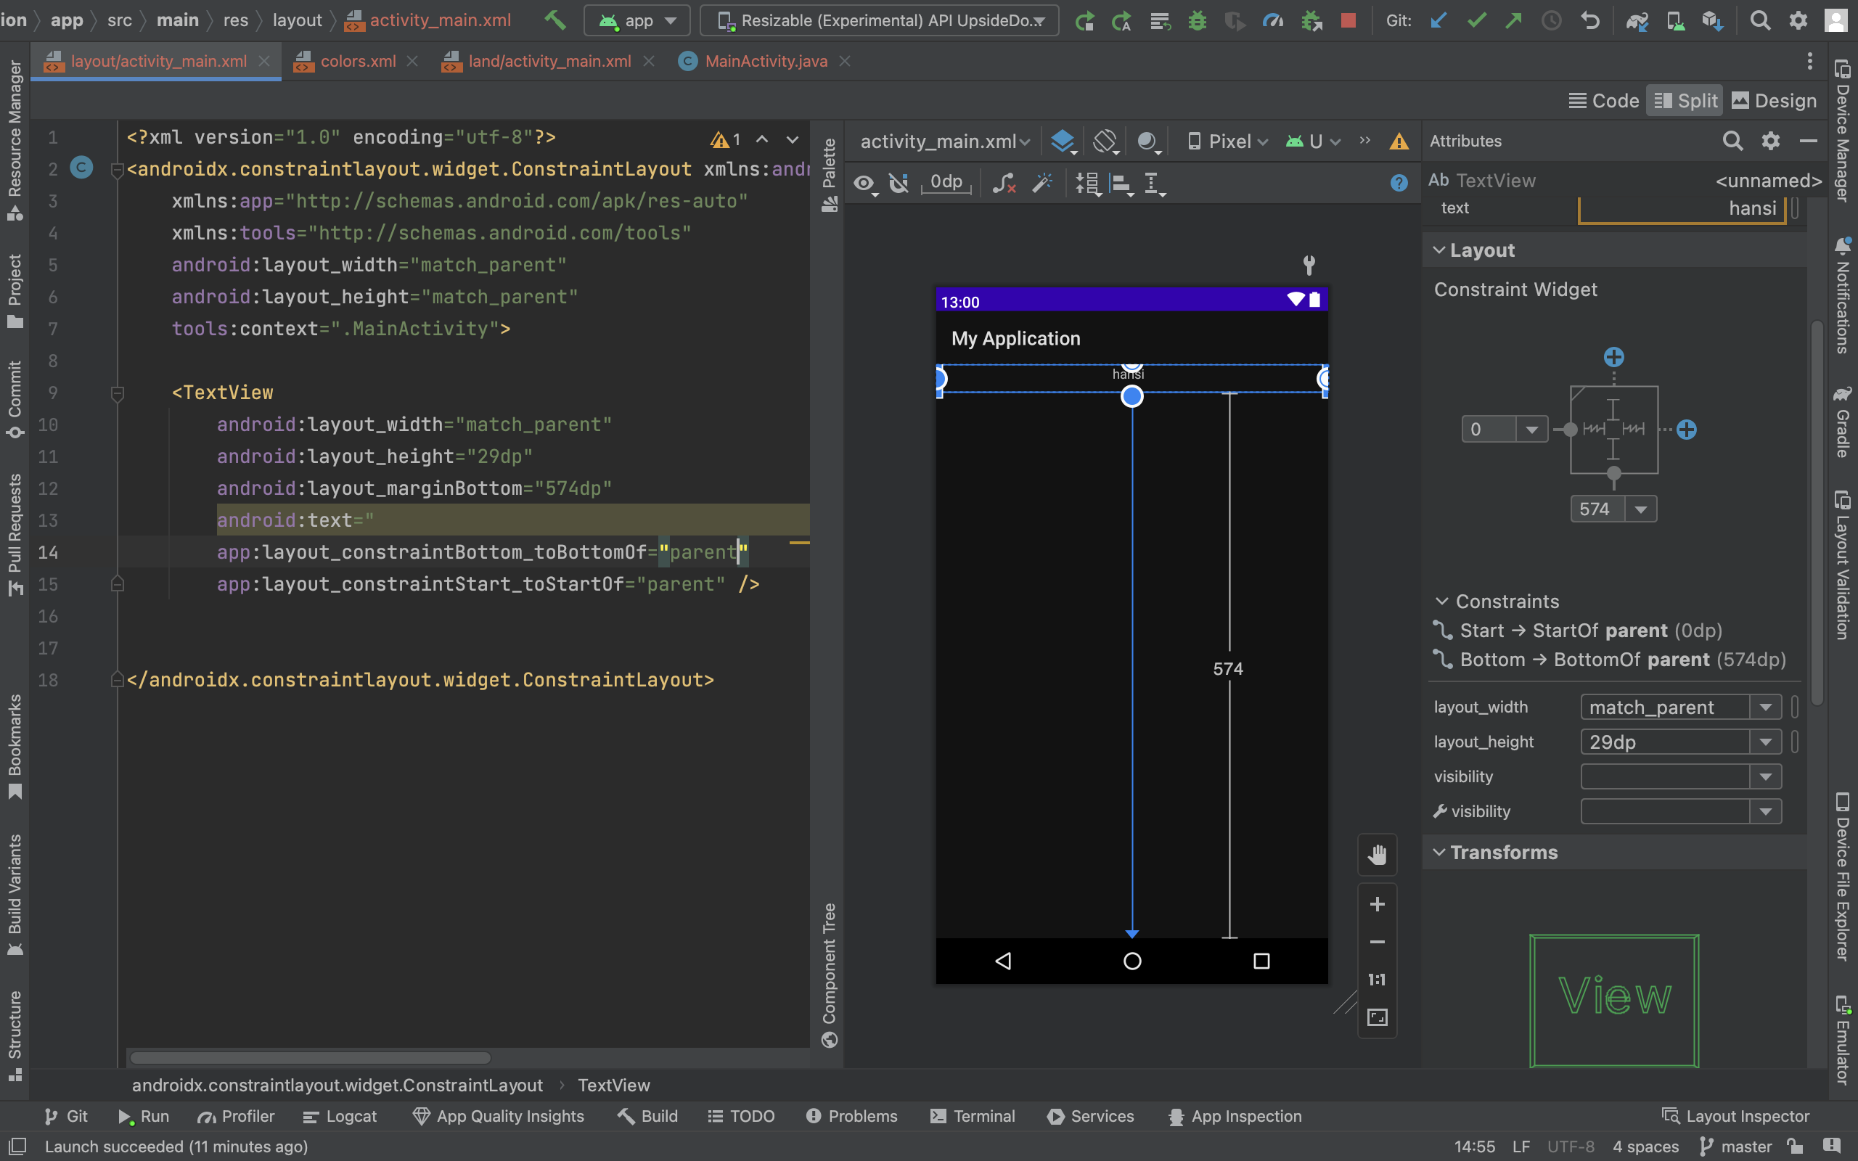

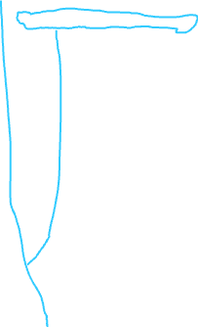

Look here two lines of code is add w.r.t selection of this here the bottom line of code specifies w.r.t parents bottom the layout margin bottom 574 dp which is specied in. first code line so in overall it means the the text view is at 574dp up from the bottom of the parent layout which is constraint layout

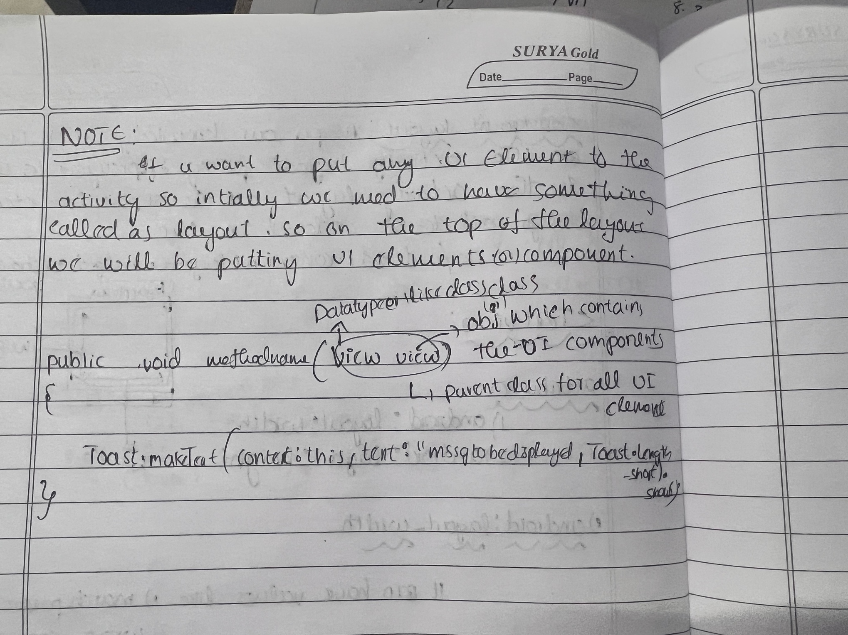

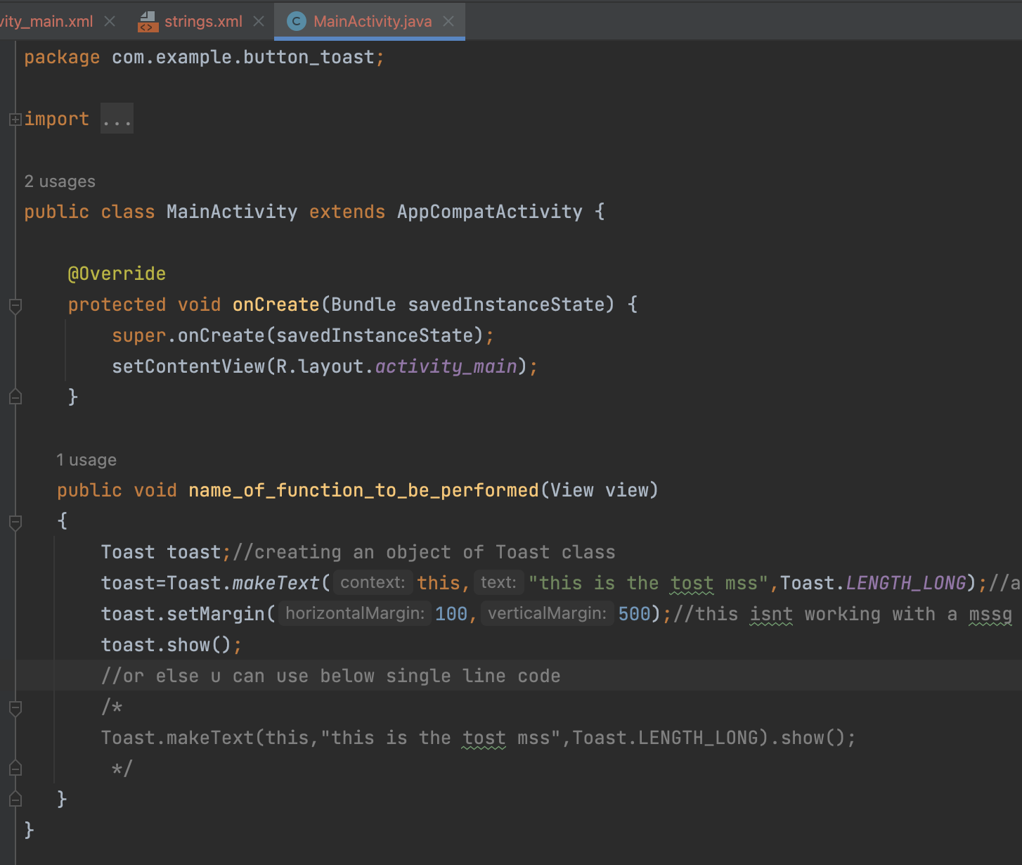

See in the above code in class onCreate u will see a line of code:

setContentView(R.layout.*activity_main*);

which means than see the path here activity_main(which Is an xml file) is in layout and layout is in R(which is R.java file which will be having all entries w.r.t all elements in res folder )